11. Implement a C Program Given an array of reg number need to search for particular reg no.

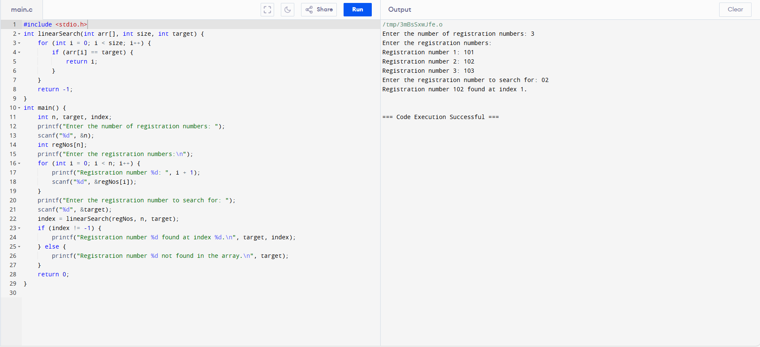

12. Implement a C Program for Haystack. There are two strings needle and haystack (or hay). You need to check if all the characters in the needle are present in haystack or not. If yes then return True (1) or False (0).

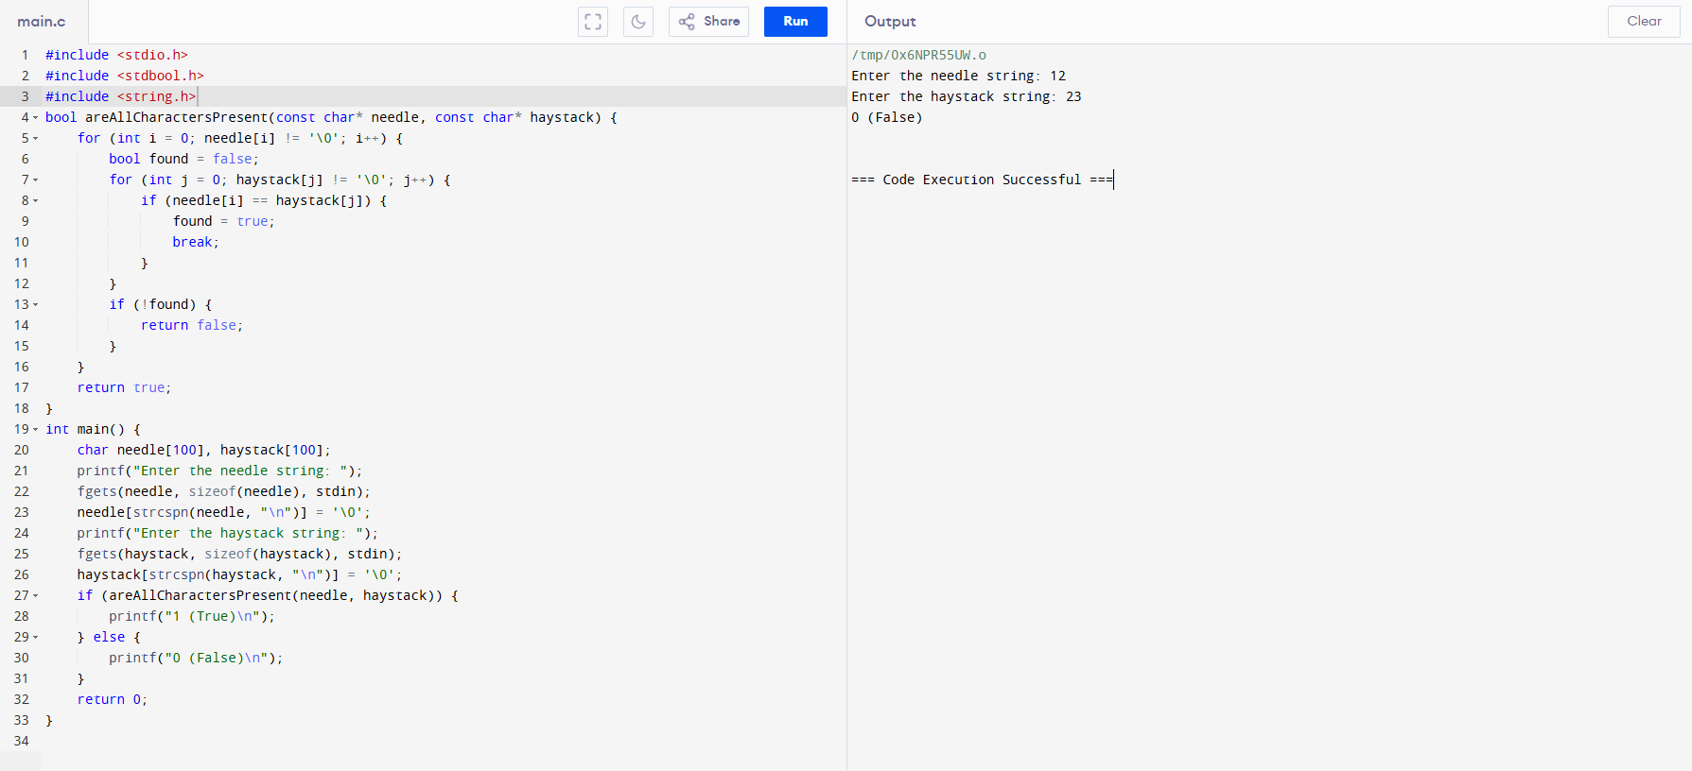

13. Write a program in C to count the frequency of each element of an array. Test Data : Input the number of elements to be stored in the array :3 Input 3 elements in the array : element - 0 : 25 element - 1 : 12 element - 2 : 43 Expected Output : The frequency of all elements of an array : 25 occurs 1 times 12 occurs 1 times 43 occurs 1 times.

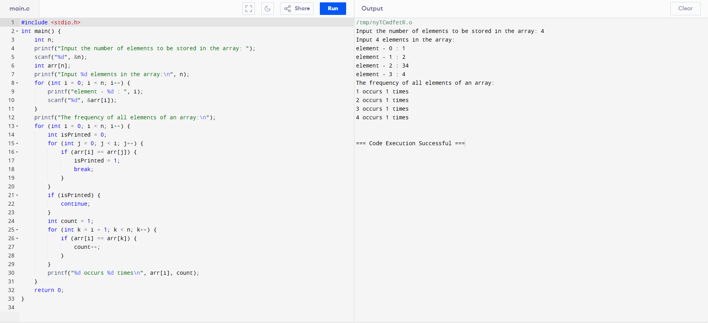

14. Implement a C Program for Given Graph convert array and print minimum edges (Prim’s Algorithm).

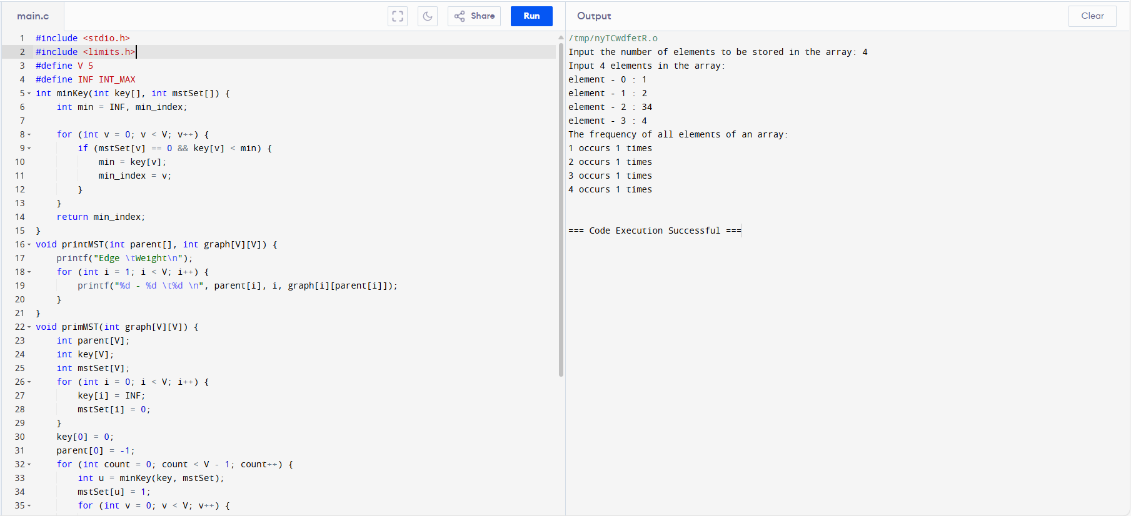

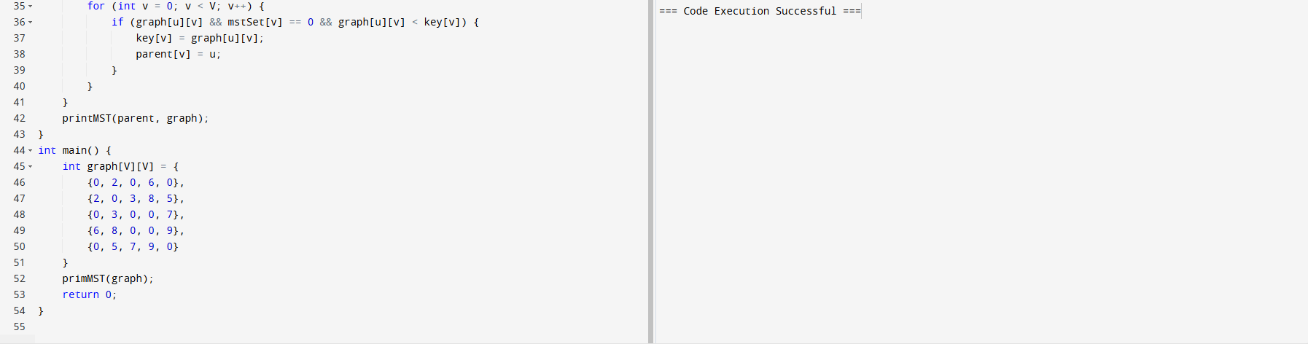

15. Write a program in C to separate odd and even integers into separate arrays. Test Data : Input the number of elements to be stored in the array :5 Input 5 elements in the array : element - 0 : 25 element - 1 : 47 element - 2 : 42 element - 3 : 56 element - 4 : 32 Expected Output : The Even elements are : 42 56 32 The Odd elements are : 25 47.

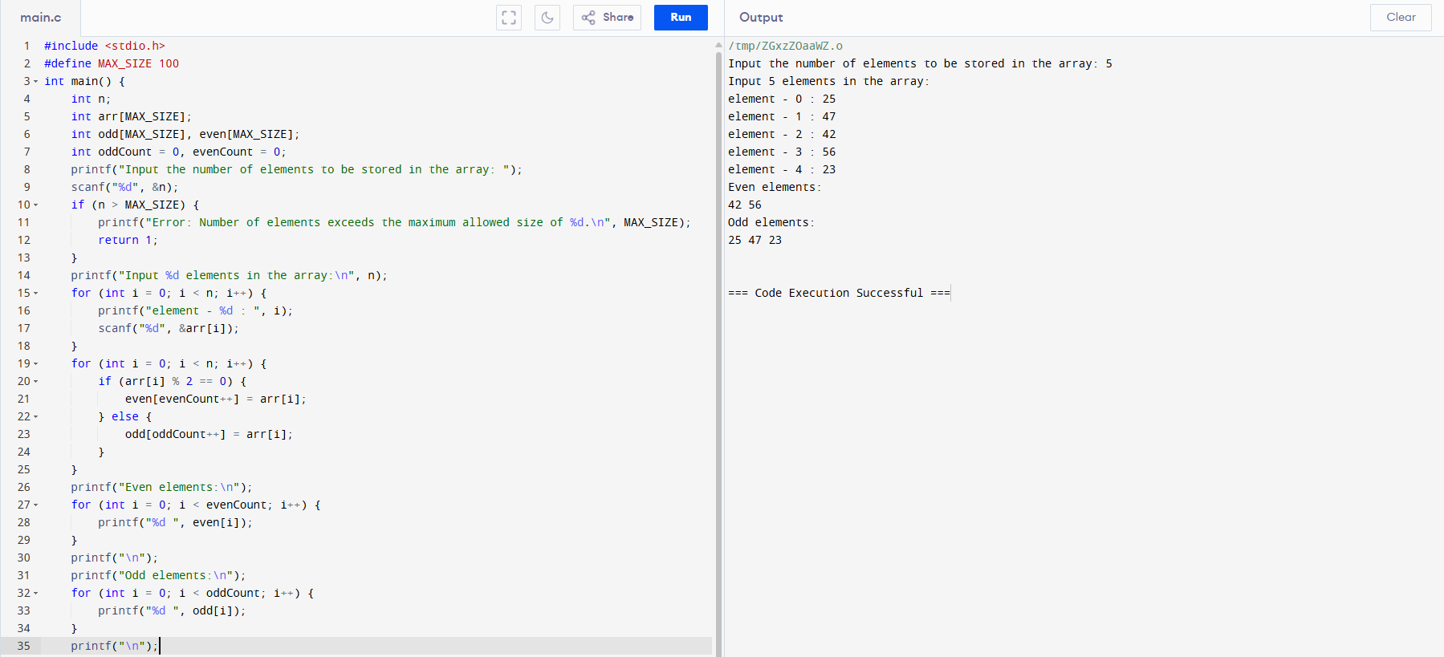

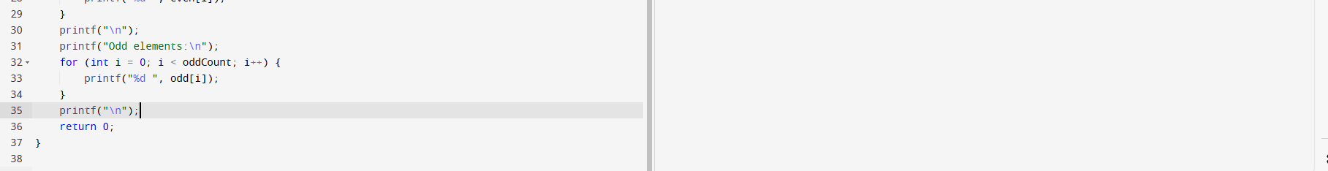

16. Implement a C Program for Given Graph - Print valid path (BFS or DFS)..

i)BFS.

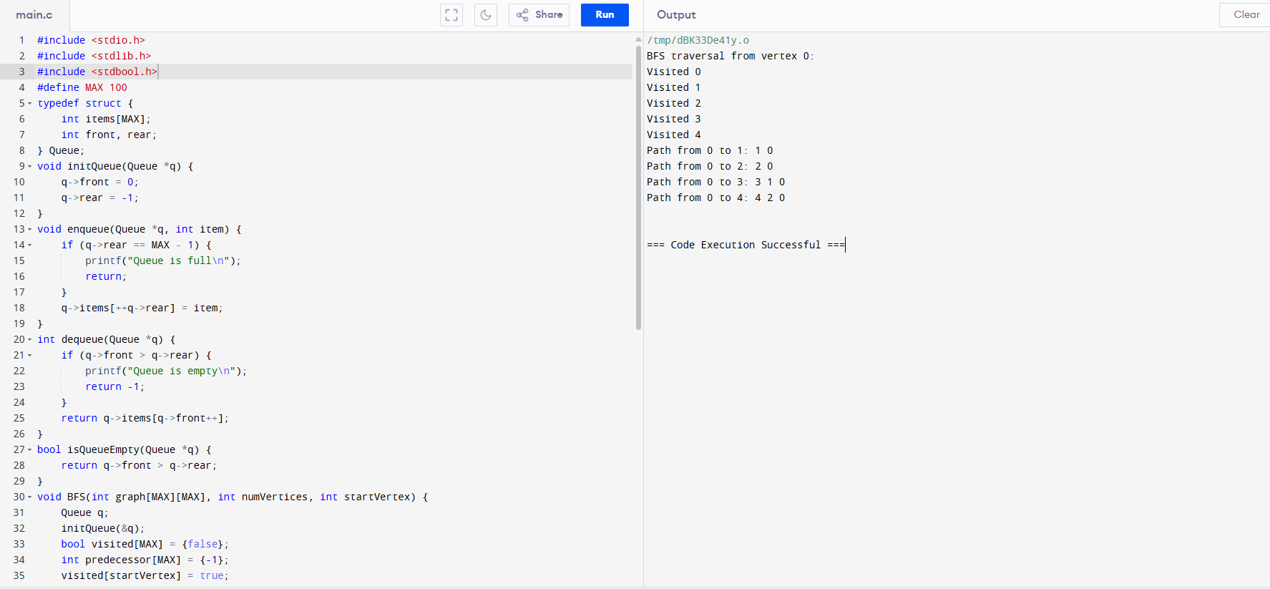

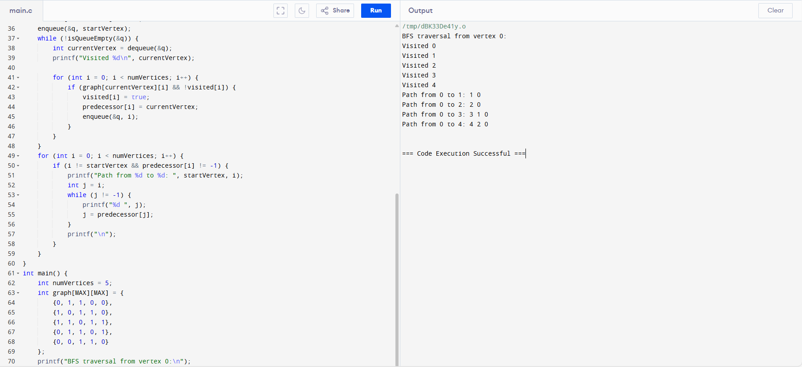

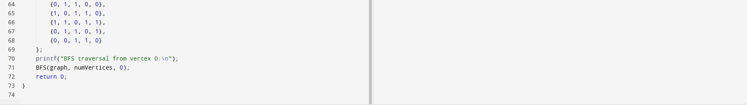

ii)DFS.

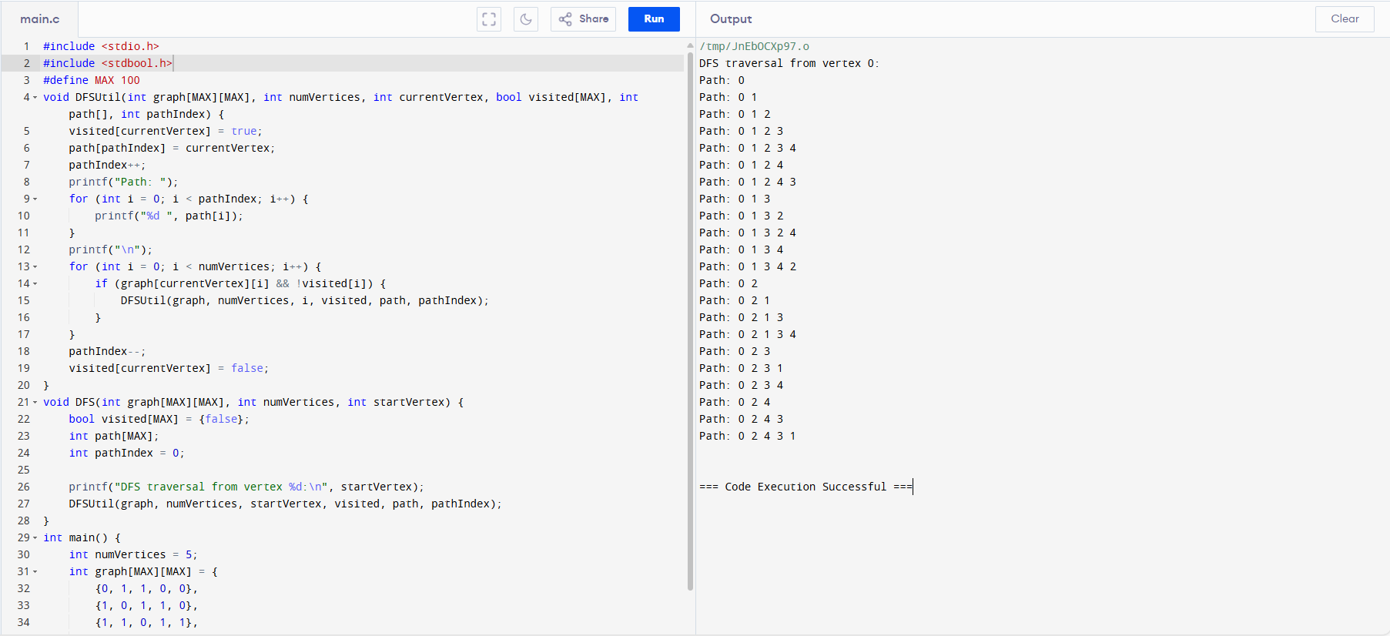

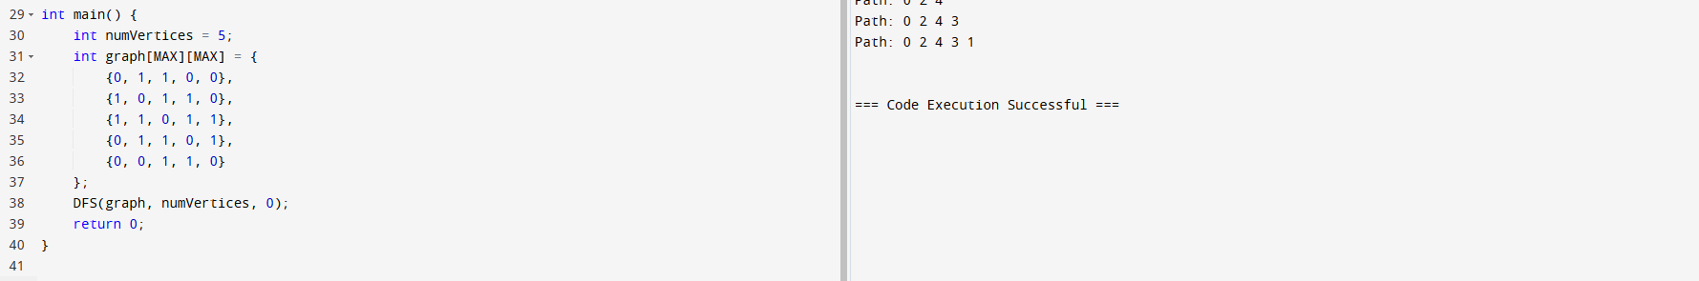

17. Implement a C Program sum of Fibonacci Series using recursion Input : n = 1 Output : 1 Input : n = 9 Output : 34 Input : n = 10 Output : 55

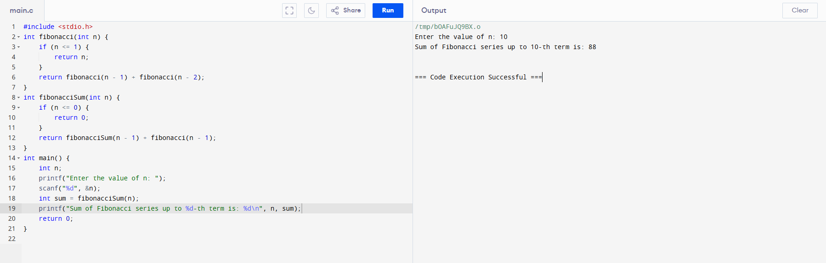

18. Implement a C Program to perform heap sort.

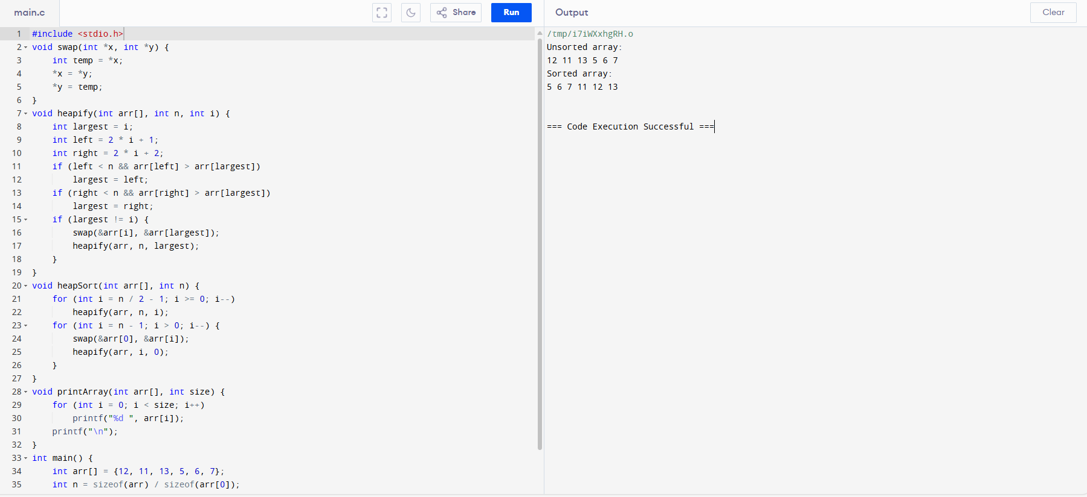

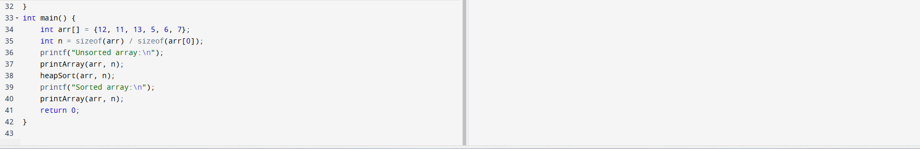

19. Implement a C Program for Finding factorial of a number using recursion Enter a positive integer: 6 Factorial of 6 = 720.

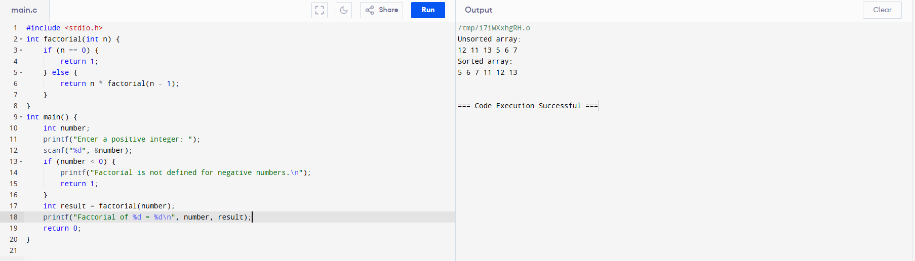

20. Implement a C Program to perform quick sort How many elements are u going to enter?: 10 Enter 10 elements: 2 3 5 7 1 9 3 8 0 4 Order of Sorted elements: 0 1 2 3 3 4 5 7 8 9.

